**Tutorial 04 –** Build WordPress CMS on Multiple Platforms and using Best Practices, extend with images, menus, themes, pages, posts, categories, tags, and plugins.

Students are required to have access to a Web Host account that they use to create and manage multiple CMS websites.  
  
If you have difficulties completing this assignment, please inform the instructor and consider working with DePaul tutors.

**Instructions for completing template:***Replace* **[bracketed red text]** *with the requested information.  
Do not include full screen shot images, or full screen shots that are reduced in size. Use a snippet tool to capture parts of the screen and insert those images into the template.  
  
Please answer all questions.***Please do not alter this template numbering.  
Each answer and screen capture are worth equal points.**

**PART A – Getting started Student Contact Information**

**1. Student Name: [STUDENT NAME – Aamir, Patel] [A01]**

**2. Student Contact Information:   
[Student Preferred Email: - Aamir8567@gmail.com] [A02]   
[Student Phone Number: - (872) 985 4361] [A03] *OPTIONAL and recommended**

**Go back to the tutorial instructions and begin working on part B.**

**Part B.1 – For WordPress site on a shared web host [B.1]**

1. Enter the following shared web host WordPress site information
   1. Shared Web Host Company Name: [ NameCheap ]
   2. Shared Web Host Company URL: [ **namecheap.com**]
   3. Shared Web Host account username: [ aamir8567]
   4. Shared Web Host password: [ Kamboli1! ]
   5. Website Admin Username: [ aapadcpate]
   6. Website Admin Password: [ nYCw2nWrtOpgV8Y1)5SmiqnU ]
   7. Database Name: [ wp747 ]
   8. Table Prefix: [ wpkx_ ]
   9. WP website URL: [ <http://aamirpatel.tech/tutorial04/> ]

**Part B.2 – For WordPress site on Pantheon (PaaS) [B.2]**

1. Enter the following shared web host WordPress site information
   1. PaaS Web Host account username: [ account username here ]
   2. PaaS Web Host password: [ account password here ]
   3. PaaS WordPress site Admin Username: [ website admin username here ]
   4. PaaS WordPress site Admin Password: [ website admin password here ]
   5. PaaS WordPress Front-end site URL: [ Pantheon website URL here ]

**Go back to the tutorial instructions and begin working on part C.**

**Part C –** Flesh out the WordPress site with Images, a theme, and a menu, pages, posts, category and tags.  
**Please make sure all Part C screen capture include the web browser address bar. [C]**

1. Take screen captures of the backend administration WordPress site Dashboard > Home  
   With Web Browser Address Bar and the “At a Glance” Dashboard section visible  
   **[C.1]  
   [ 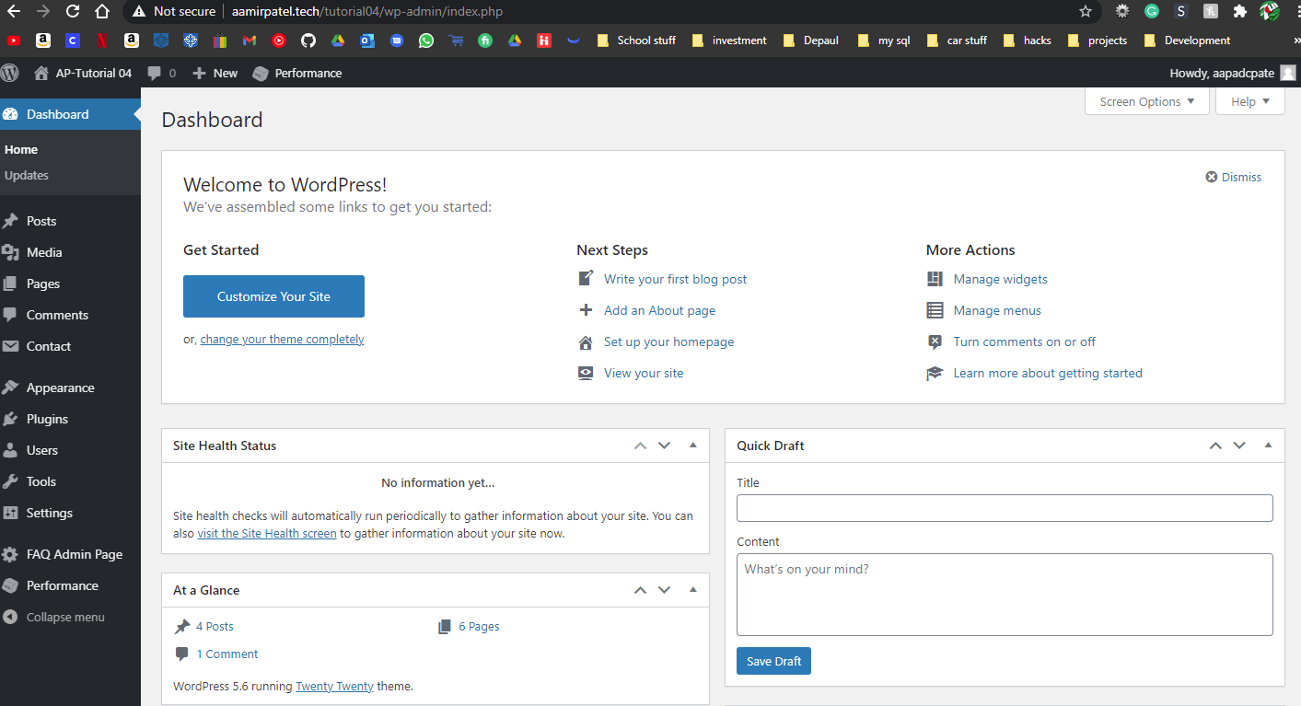]**
2. Take screen captures of the backend administration WordPress site   
   Dashboard > Media page – with the media library in GRID mode   
   **[C.2]  
   [ 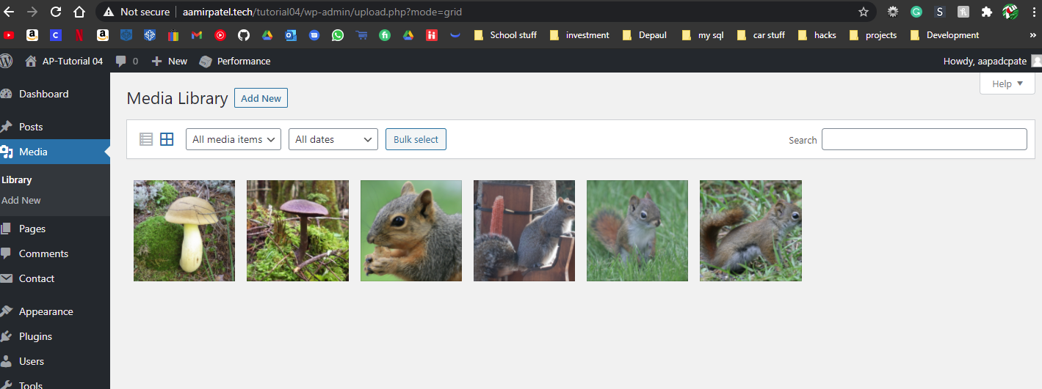]**
3. Take screen captures of the backend administration WordPress site   
   Dashboard > Appearance > Themes   
   **[C.3]  
   [ 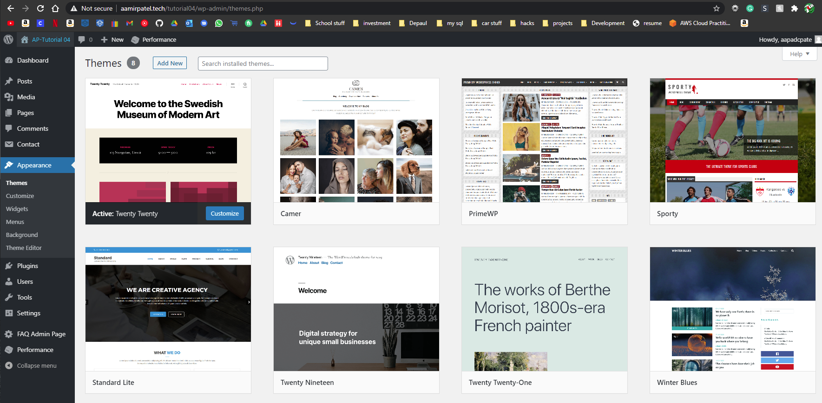]**
4. Take screen captures of the backend administration WordPress site   
   Dashboard > Appearance > Menus   
   **[C.4]  
   [ 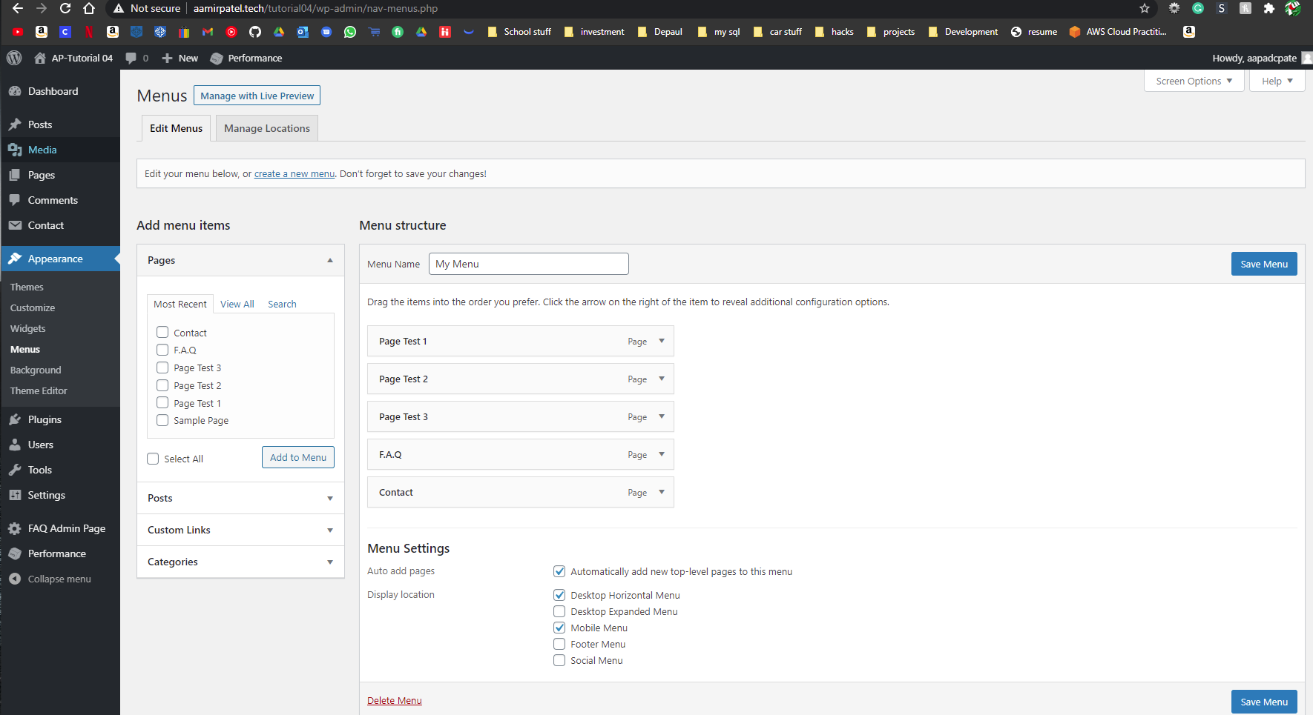]**
5. Take screen captures of the backend administration WordPress site Dashboard > Pages   
   **[C.5]  
   [ 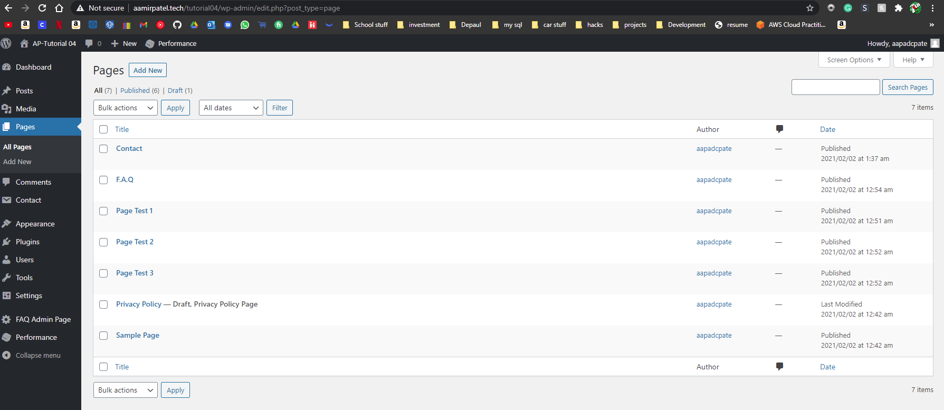]**
6. Take screen captures of the backend administration WordPress site Dashboard > Posts  
   **[C.6]  
   [ 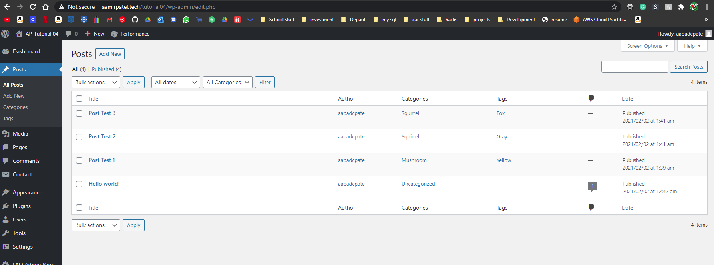]**

**Go back to the instructions and continue at Part D**

**Part D – Extend WordPress with Widgets**

**Please make sure all Part D screen capture include the web browser address bar. [D]**

1. Take screen captures of the backend administration WordPress site Dashboard > Appearance > Themes **[D.1]  
   [ 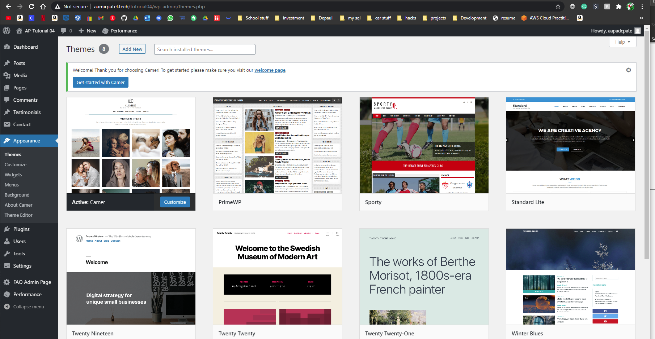]**
2. Take screen captures of the backend administration WordPress site Dashboard > Plugins > Installed Plugins – showing the installed and activated Widget Plugins **[D.2]  
   [ 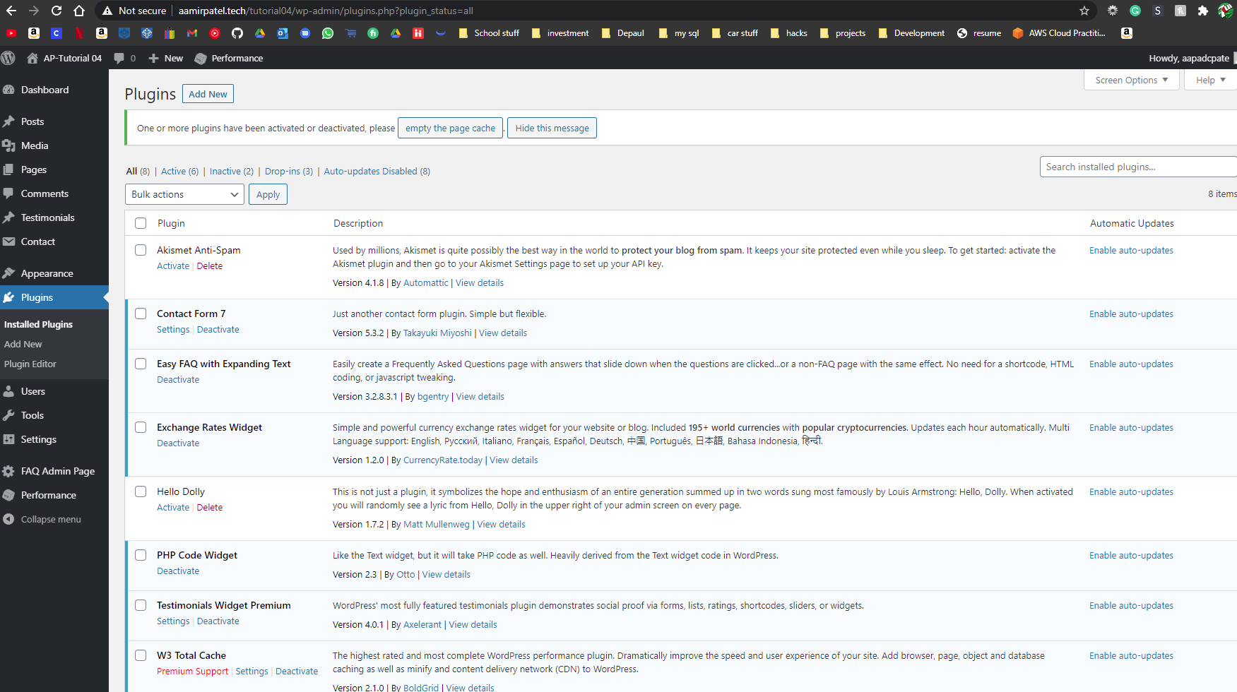]**
3. Take screen captures of the backend administration WordPress site Dashboard > Appearance > Widgets - this may take several screen captures to capture everything. **[D.3]  
   [ 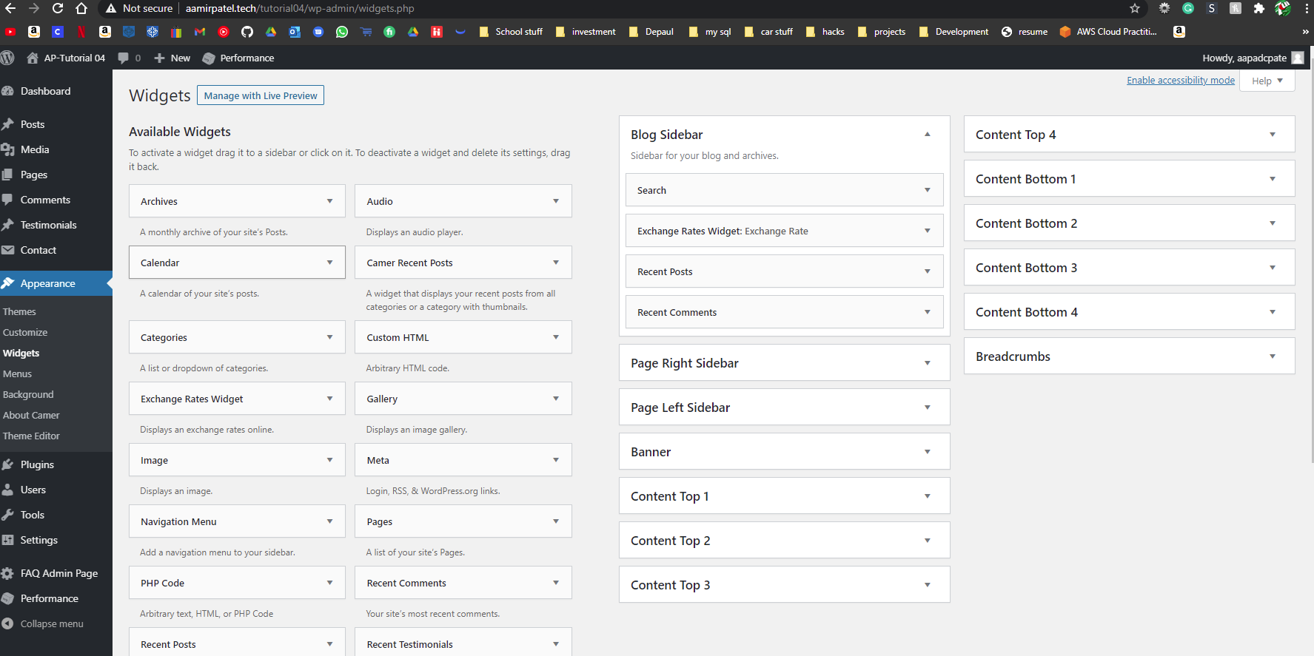]**

**Go back to the instructions and continue at Part E.**

**Part E – Comments and Discussion**

**Please make sure all Part E screen capture include the web browser address bar. [E]**

1. Take screen captures of the backend administration WordPress site Dashboard > Posts  
    showing post comments **[E.1]  
   [ 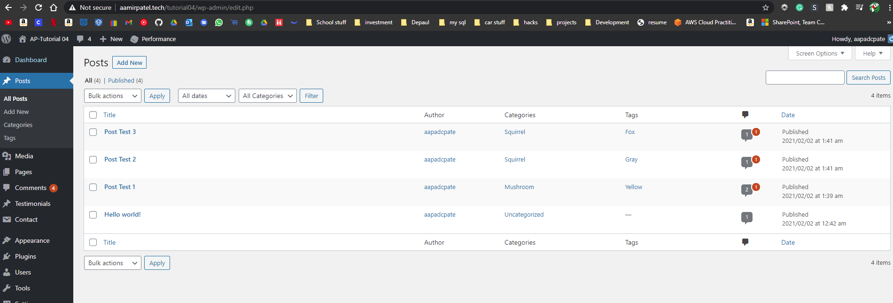]**
2. Take screen captures of the backend administration WordPress site Dashboard > Pages **[E.2]  
   [ 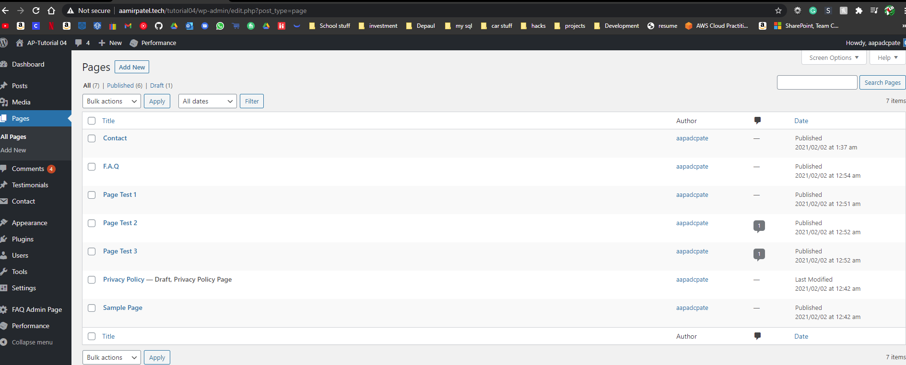]**
3. Take screen captures of the backend administration WordPress site Dashboard > Settings > Discussion page **[E.3]  
   [ 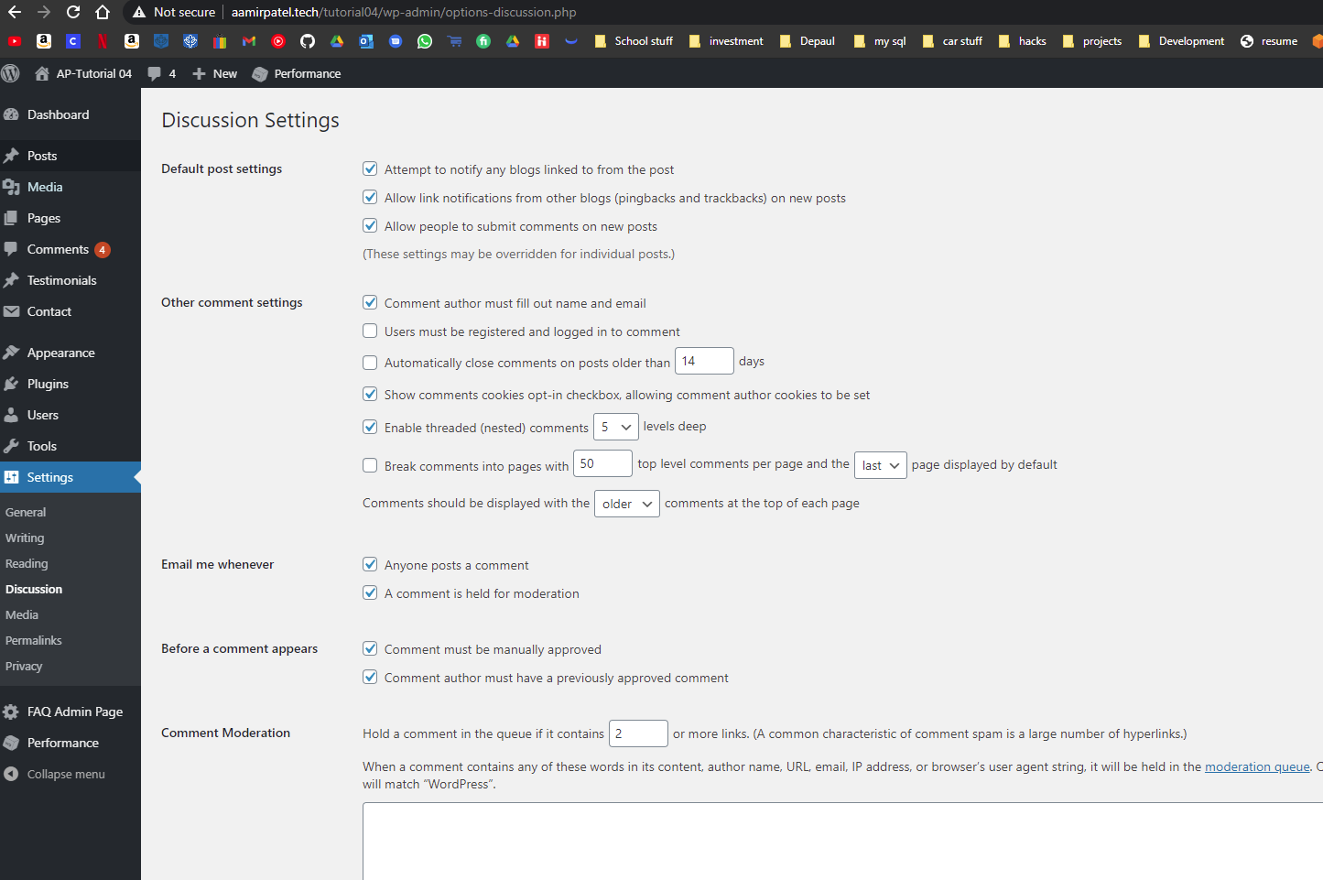]**

**Go back to the instructions and continue at Part F.**

**Part F – Migrations**

**Please make sure all Part F screen capture include the web browser address bar. [F]**

**Part F.1 – Codeanywhere account and WordPress site Information [F.1]**

1. Enter the following shared web host WordPress site information
   1. Codeanywhere account username(email): [ [mpate180@depaul.edu](mailto:mpate180@depaul.edu) ]
   2. Codeanywhere account password): [ [Kamboli1!](mailto:mpate180@depaul.edu) ]
   3. WordPress site Admin Username: [ **mapjkam** ]
   4. WordPress site Admin Password: [ **EJrsHR3TNa2SVfsl$21asfvcxzc**]
   5. Tutorial WP Site URL: [ https://ap1tutorial4ca--mpate18024699.codeanyapp.com/ ]

**Go back to the instructions and continue at Part F.2**

**Part F.2 – Codeanywhere [F.2]**

1. Take screen captures of the backend administration WordPress site Dashboard > Plugins **[F.2.1]  
   [ 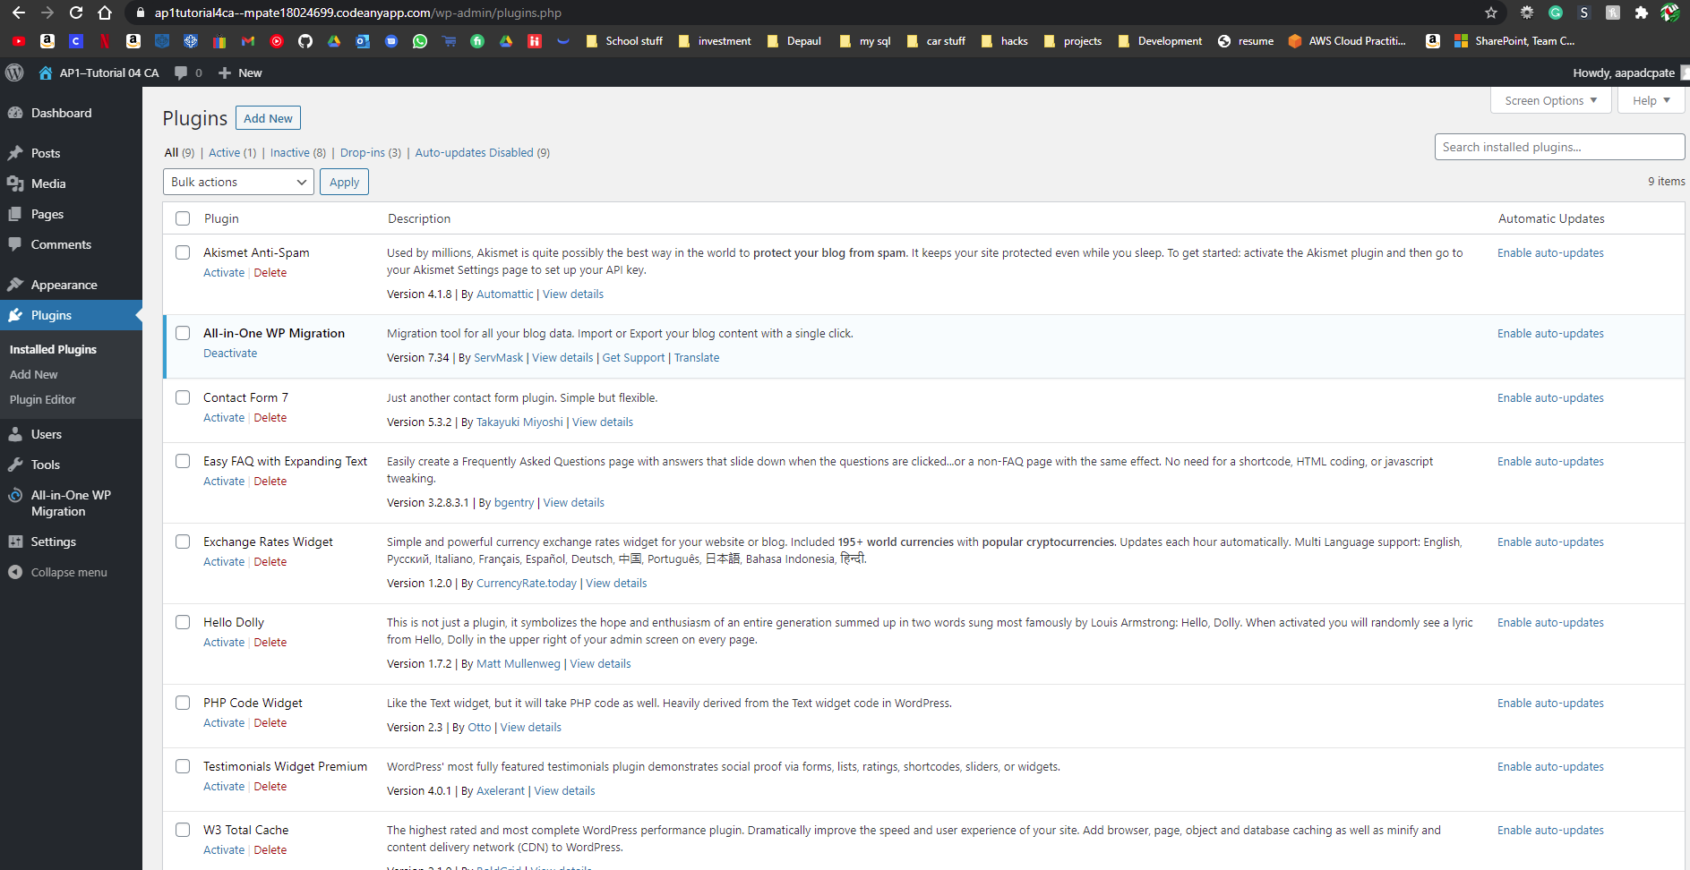 ]**
2. Was the Shared Web Host or Pantheon (PaaS) to Codeanywhere migration successful? **[F.2.3]  
   [ Yes and No,]**
3. If you answered No to the previous question, please record any errors, or information on what happened. And if you have not done so already, please contact the instructor for help, so you do not lose points on the assignment, which also has a WordPress migration? **[F.2.4]  
   [ The first backup that I had created would not let me access the website, although I used the correct username and pass. But I reinstalled WordPress on codeanywhere and that seemed to have solved the issue.  
   [You can put screen captures here also ]**
4. Were you able to reestablish the baseline WP site on Codeanywhere successfully? **[F.2.5]  
   [ Yes ]**
5. If you answered No to the previous question, please record any errors, or information on what happened. And if you have not done so already, please contact the instructor for help, so you do not lose points on the assignment, which also has a WordPress migration? **[F.2.6]  
   [ What went wrong?]  
   [You can put screen captures here also ]**

**Go back to the instructions and continue at Part G.**

**Part G – Custom Modules**

**Please make sure all Part G screen capture include the web browser address bar. [G]**

**G.1 Shared Web Host + CPanel or Pantheon (Paas) Platform:**

1. Take screen captures of the site folder, with the wp-content/plugins folder and custom plugin folders. Pantheon users, screen capture of FileZilla. **[G.1.1]  
   [ 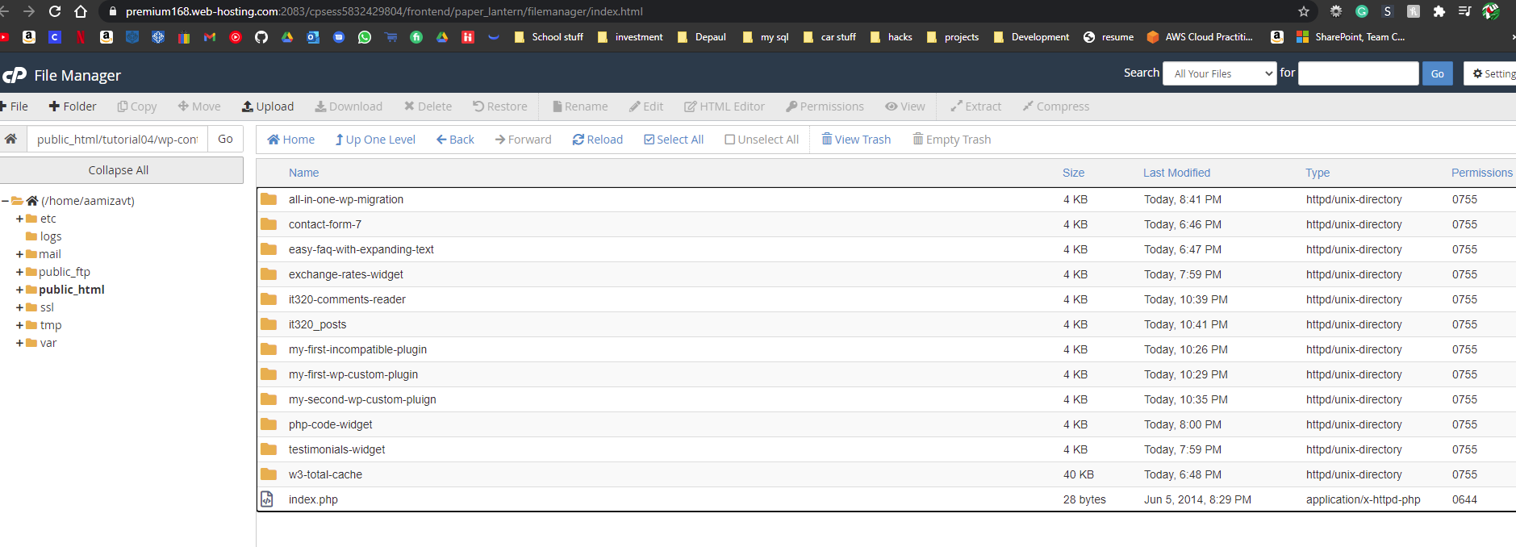]**
2. Take screen captures of the backend administration WordPress site Dashboard > Plugins showing the two custom plugins enabled **[G.1.2]  
   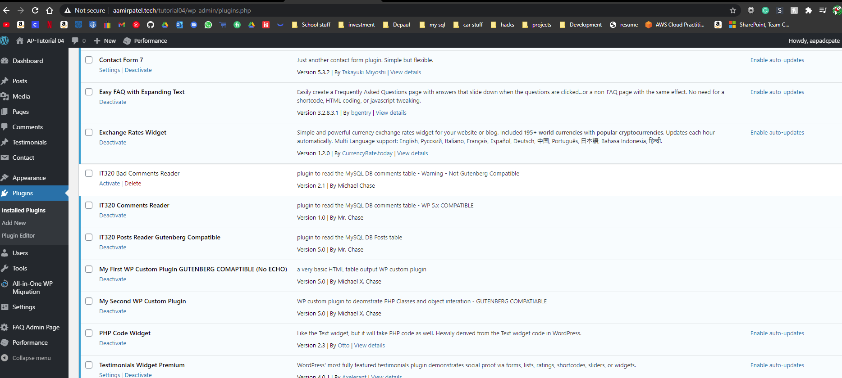**

**]**

1. Take screen captures of the backend administration WordPress site Dashboard > Pages **[G. .13]  
   [ 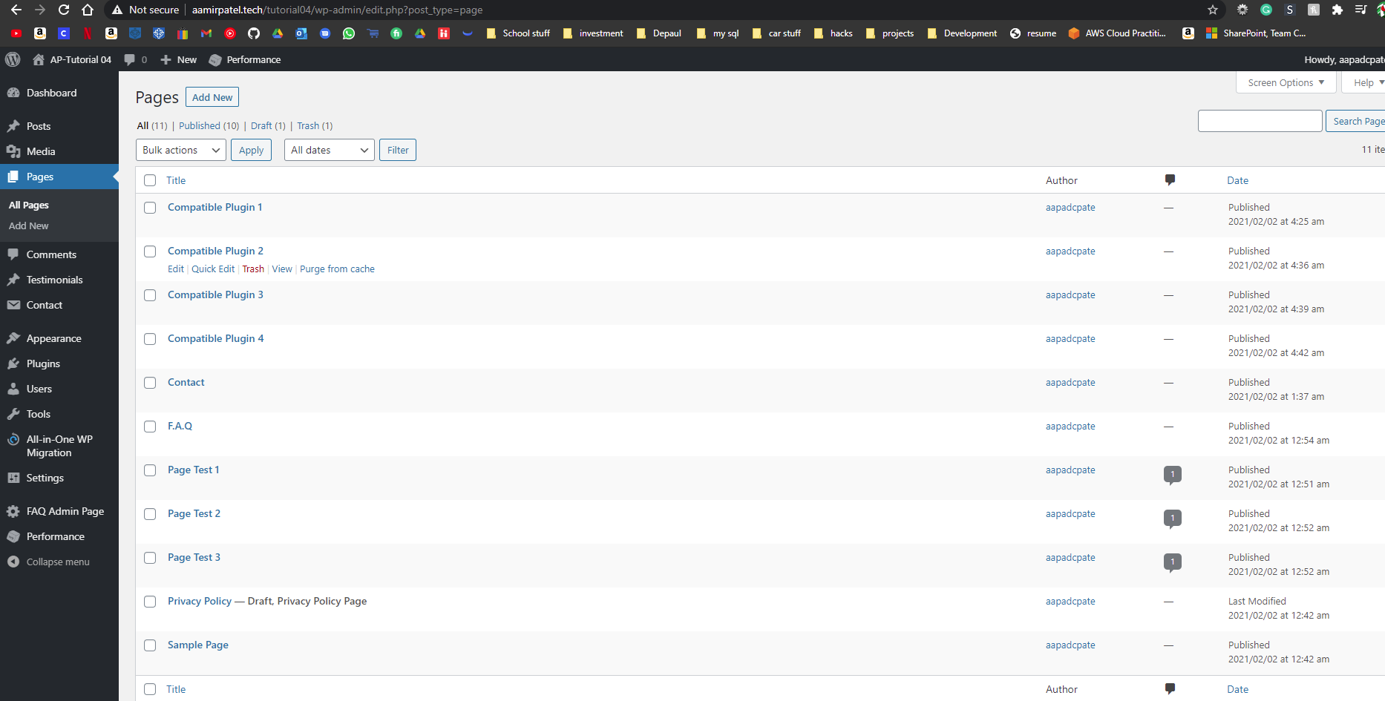]**
2. Front-end screen capture showing the First Custom Plugin page out.  
   Please verify that your screen capture shows the web browser address bar **[G.1.4]  
   [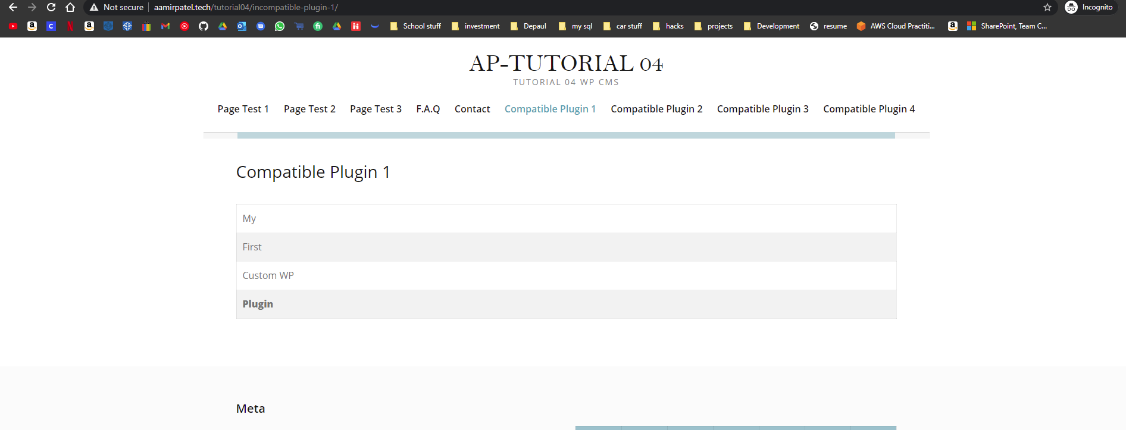]**
3. Front-end screen capture showing the Second Custom Plugin page out.  
   Please verify that your screen capture shows the web browser address bar **[G.1.5]  
   [**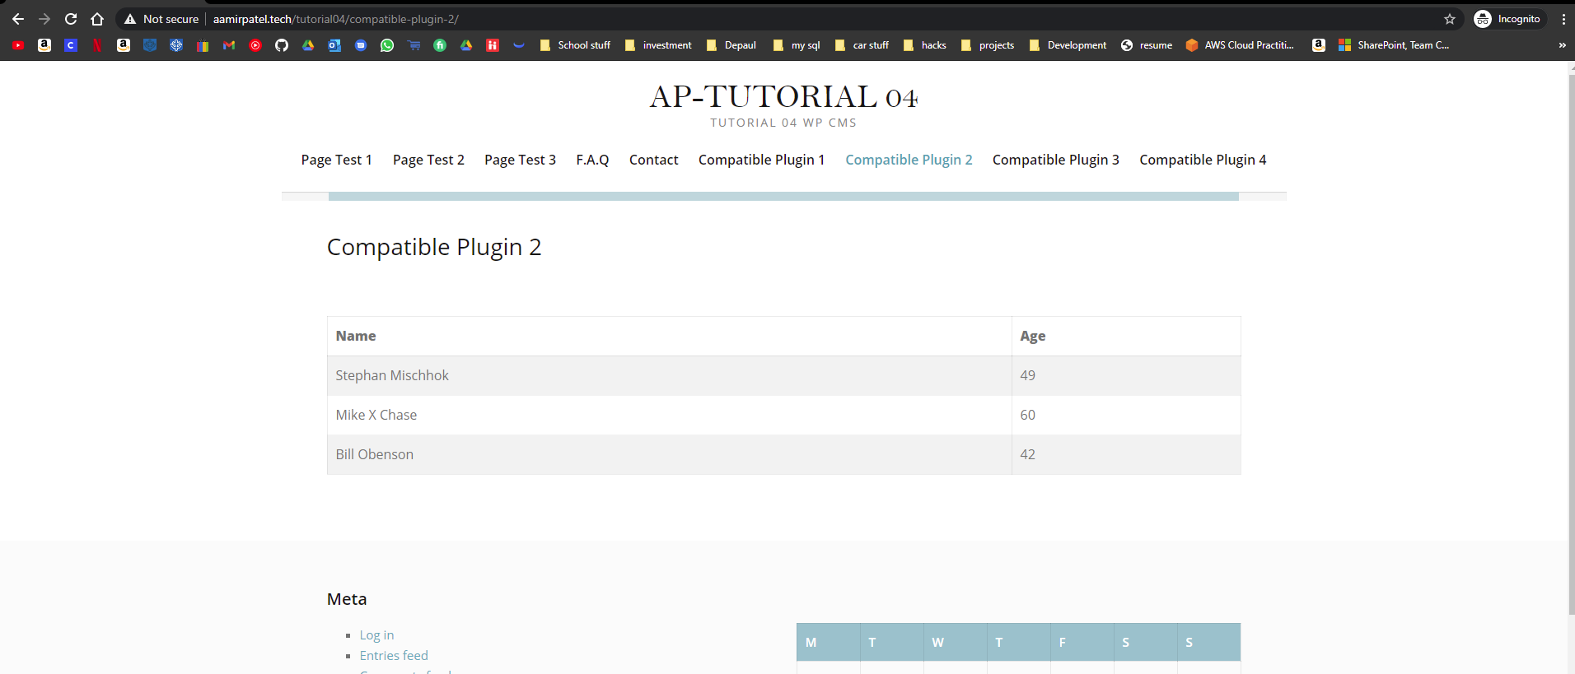

**]**

**G.2 Cloud – Codeanywhere Platform:**

1. Take screen captures of the site folder, with the wp-content/plugins folder and custom plugin folders **[G.2.1]  
   [ 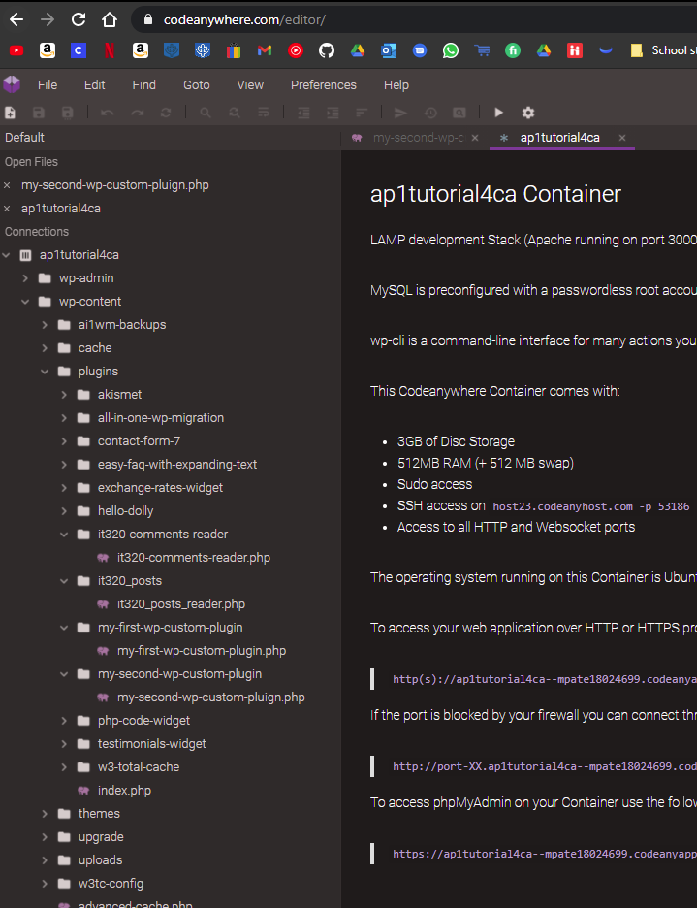]**
2. Take screen captures of the backend administration WordPress site Dashboard > Plugins showing the two custom plugins enabled **[G.2.2]  
   [ 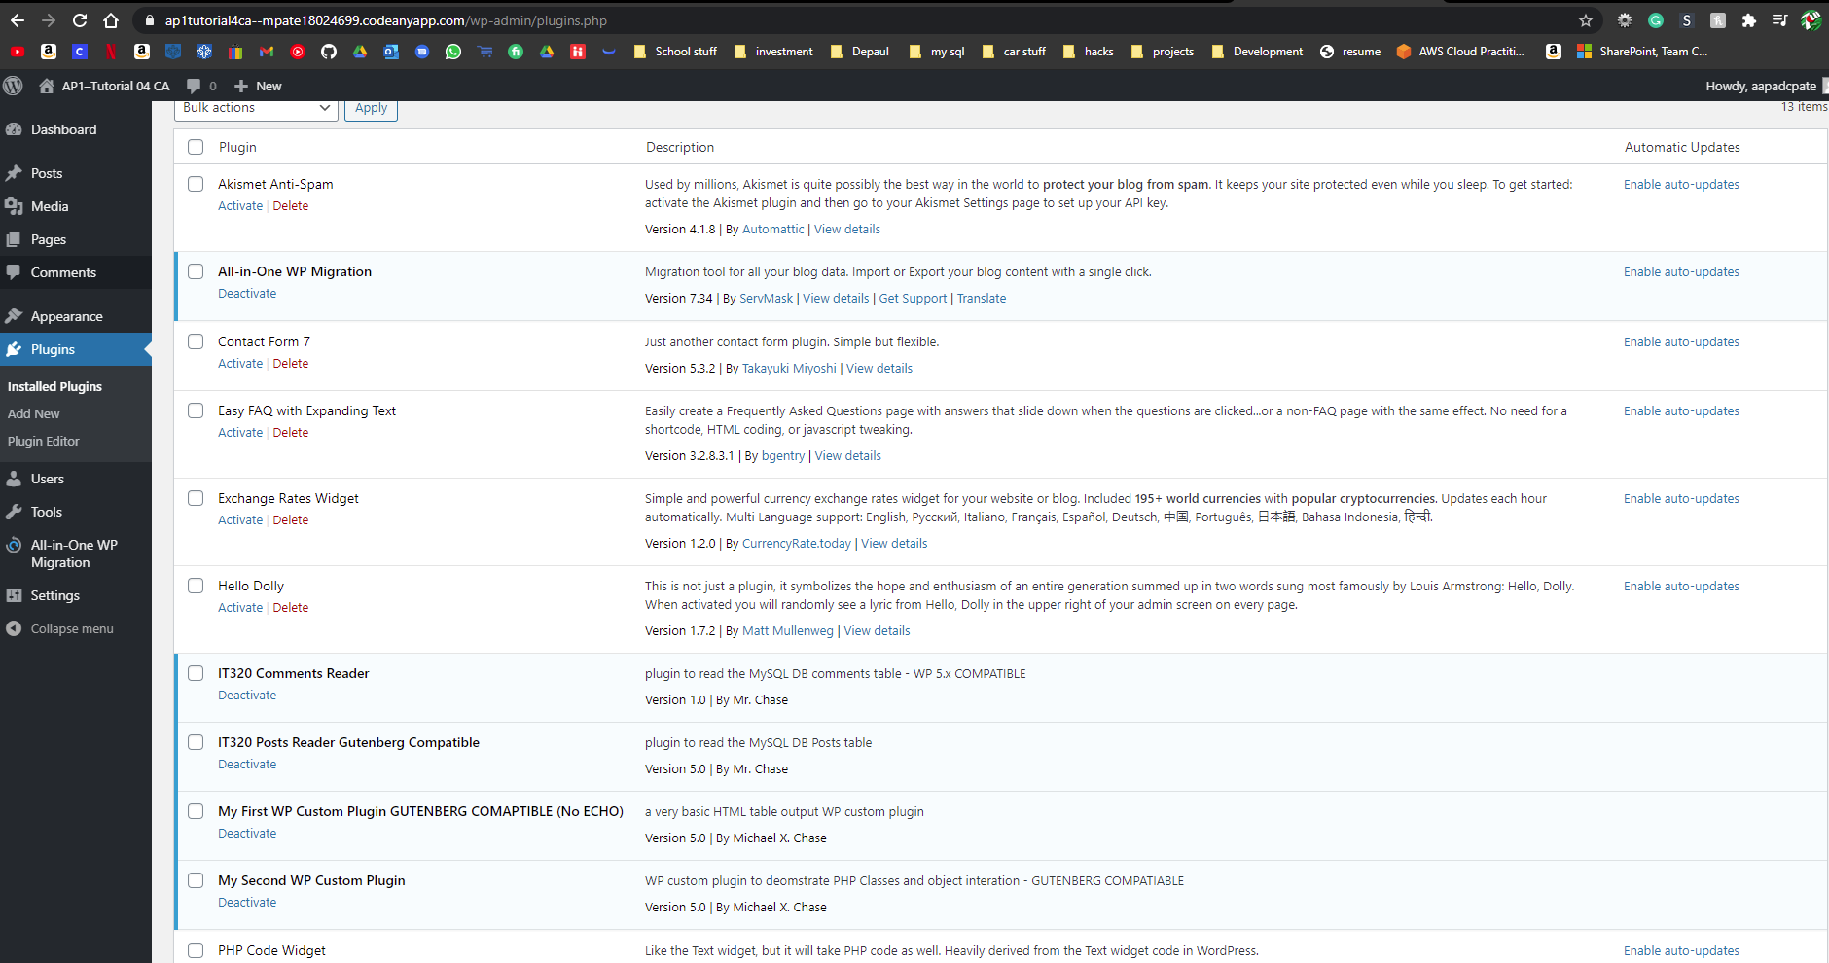]**
3. Take screen captures of the backend administration WordPress site Dashboard > Pages **[G.2.3]  
   [ 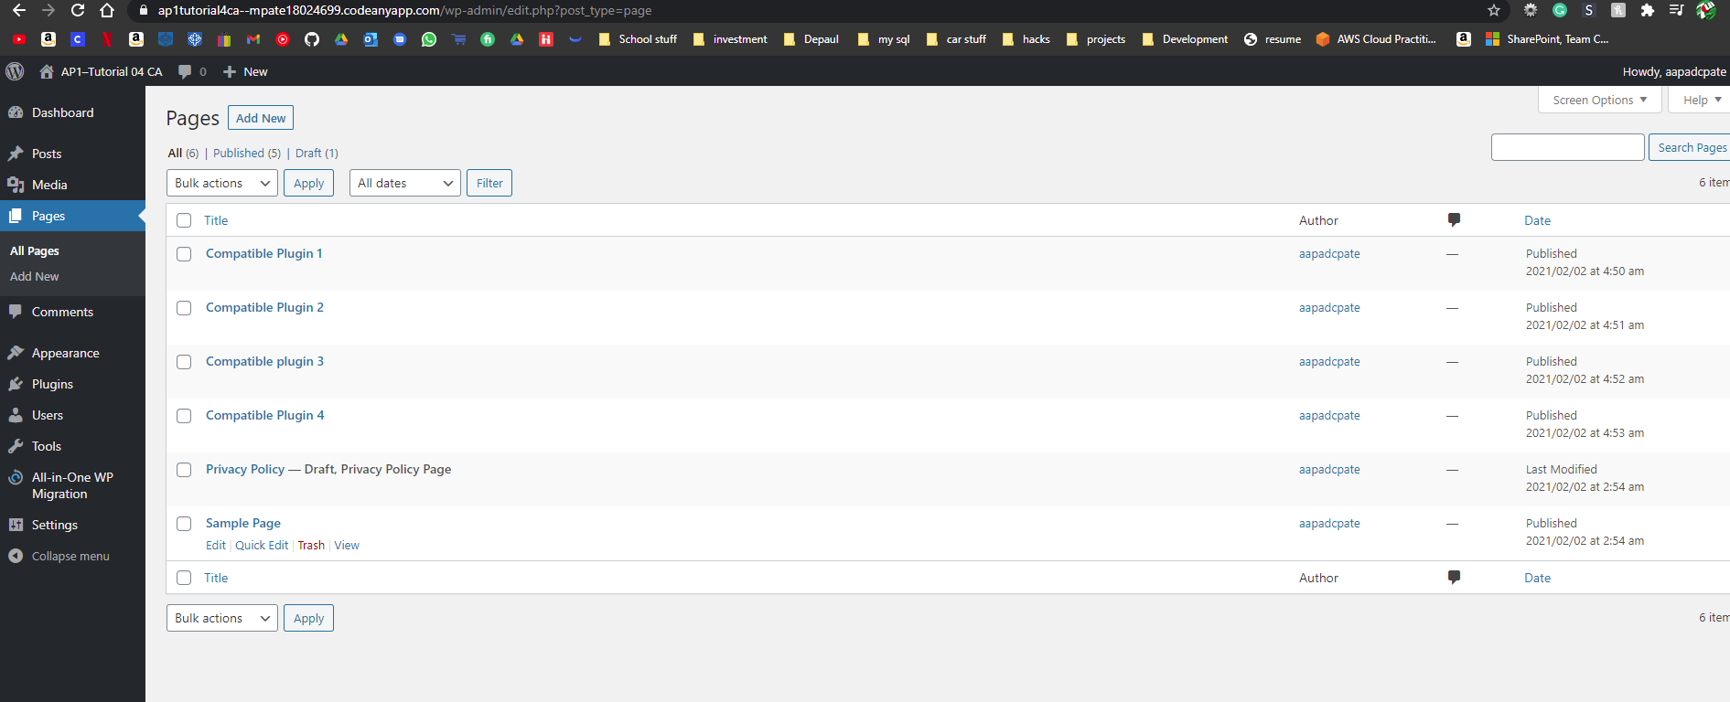]**
4. Front-end screen capture showing the First Custom Plugin page out.  
   Please verify that your screen capture shows the web browser address bar **[G.2.4]  
   [ 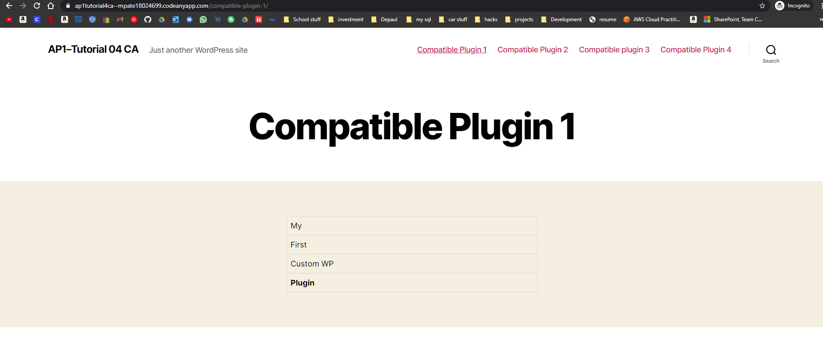]**
5. Front-end screen capture showing the Second Custom Plugin page out.  
   Please verify that your screen capture shows the web browser address bar **[G.2.5]  
   [ 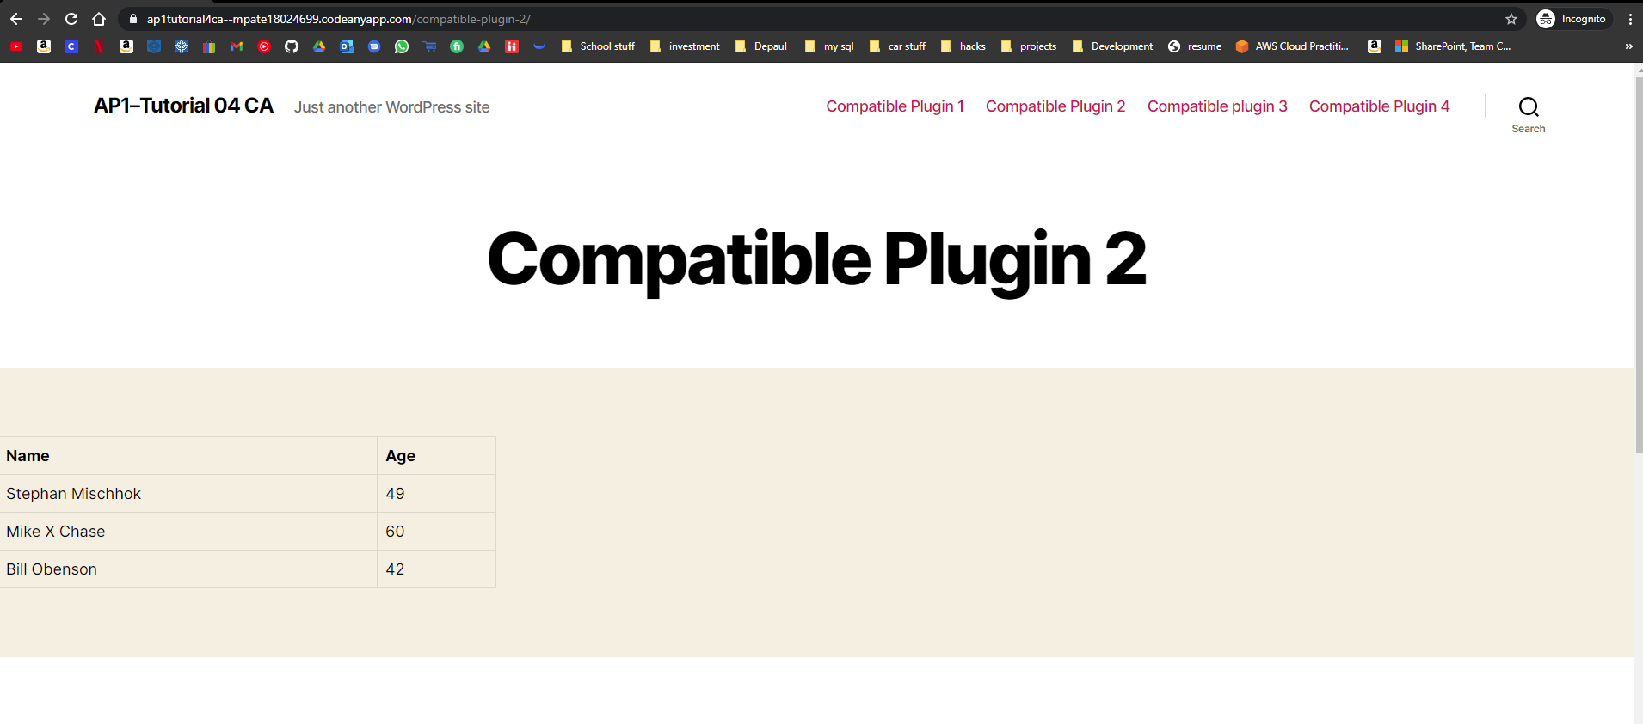]**

**Go back to the instructions and continue at Part H.**

**Part H – PHP QUESTIONS**

**Testing PHP Programs using PHP Emulation Websites:**

* Online PHP test sites:
  + <http://phptester.net>
  + <http://www.writephponline.com/>
  + <http://sandbox.onlinephpfunctions.com/>
  + <https://wtools.io/php-sandbox>
* How you test your script depends on which test site you use.
* **Each PHP emulation test site works slightly different**.
* Please read the site instructions before testing your PHP code.

1. Write and test PHP code that does the following:
   1. Creates a PHP class named dog with member variables named breed (string), and intelligence (integer 1-5). Create get and set methods for both member variables. Write code that creates a dog object named Husky and set all member variables to values of your choice and echo each objects values by calling the objects get methods.
   2. **Test your code using an online PHP emulator and paste the code and results in the table cell below. You do not have to output to a HTML table. In fact doing so may make your PHP code to big to work in PHPTester and it will fail with a 417 error.**

**IF you do get a 471 error running your code on PHP tester, then please use a different PHP Web Emulator like:  
http://www.writephponline.com/**

**https://wtools.io/php-sandbox**

|  |
| --- |
| Copy and paste the code block and record the results on the next row. A screen shot from the PHP test site will be the best way to not affect template format. Please try not to change the template numbering or format. |
|  |

1. Examine the image below and answer the following questions is the function argument $num a default argument or an optional argument? Is the function argument pass by reference or pass by value?

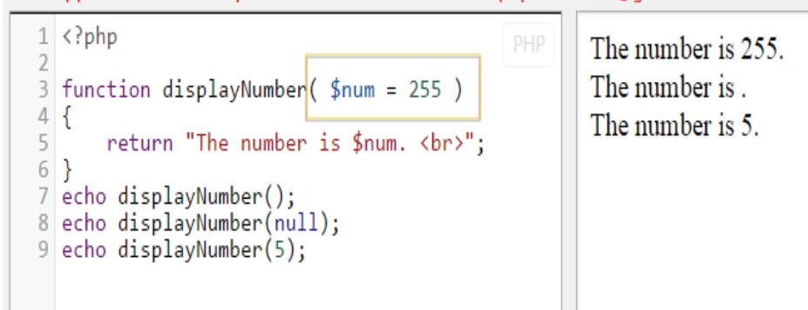

|  |
| --- |
| 1. Is the function argument a default argument or an optional argument? |
| * Default Argument |
| 1. Is the function argument pass by reference or pass by value? |
| * Pass By Value |
|  |

1. Examine the image below and answer the following questions about the function arguments $flavor and $type. Define each argument as either regular, default, or optional.   
   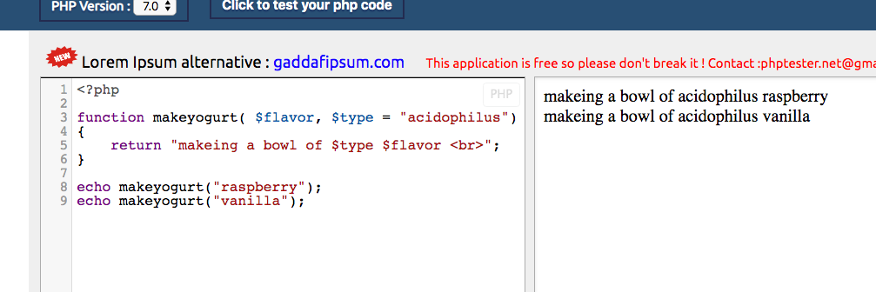

|  |
| --- |
| 1. Is the function argument $flavor a regular, default, or an optional argument? |
| * Regular Argument |
| 1. Is the function argument $type a regular, default, or an optional argument? |
| * Default Argument |
|  |

**Please go back to the instructions and work on Part I.**